Information And Cyber Security
Unit : 5 & 6

Q. Explain Kerberos. What four requiremets were defined for Kerberos?
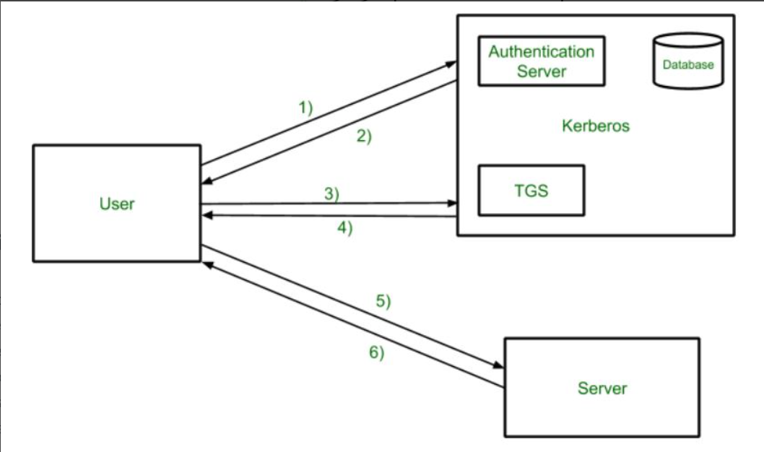
Kerberos is a network authentication protocol using trusted third-party (KDC) to verify user/service identities via tickets and symmetric-key crypto, preventing password exposure over insecure networks, aiming for secure, reliable, transparent, and scalable authentication, crucial for single sign-on. Its core requirements are Security (no masquerading), Reliability (distributed, available), Transparency (user unaware), and Scalability (large networks), ensuring strong, seamless authentication in environments like Active Directory.

What is Kerberos?
- A Protocol for Trust: Kerberos is a network authentication protocol that allows nodes communicating over a non-secure network to prove their identity to each other securely.
- Ticket-Based System: It uses "tickets" as credentials, issued by a trusted Key Distribution Center (KDC), to authenticate users and services without sending passwords across the network.
- Components: Key parts include the Client, the Server, and the KDC (which has an Authentication Server (AS) and Ticket Granting Server (TGS)).
The Four Core Requirements for Kerberos
CS.hofstra.edu defined these key design goals:
- Secure: Prevent unauthorized access (masquerading) using strong cryptography, ensuring data confidentiality and integrity.
- Reliable: Achieved through a distributed server architecture, often with backup servers, ensuring the authentication service remains available.
- Transparent: The user ideally shouldn't notice the complex authentication; it should happen seamlessly in the background (like a single sign-on experience).
- Scalable: Must support a large number of clients and servers efficiently, typical in large enterprise networks.
How it Works (Simplified)
- User logs in, proving identity to the KDC's Authentication Server (AS).
- AS issues a Ticket-Granting Ticket (TGT).
- User presents TGT to the Ticket-Granting Server (TGS) to request access to a specific service.
- TGS issues a Service Ticket.
- User presents the Service Ticket to the target Server, gaining access.

Q. What is the role of X.509 in cryptography?
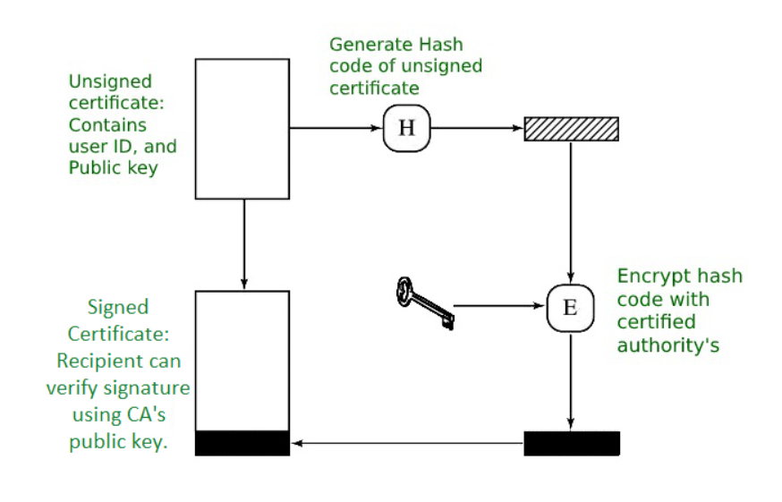
X.509 is a crucial standard in cryptography and cybersecurity, defining the format for digital certificates that act as digital ID cards, binding a public key to an entity (user, server, device) for authentication, encryption, and integrity. It enables secure online activities like HTTPS (TLS/SSL), secure email (S/MIME), and code signing by allowing parties to verify identities and establish encrypted, trusted channels for secure data exchange within Public Key Infrastructure (PKI).

Key Roles in Cryptography & Security:
- Identity Verification (Authentication):
  - X.509 certificates confirm that a public key truly belongs to the claimed owner, preventing impersonation and man-in-the-middle attacks.
  - Issued by trusted Certificate Authorities (CAs) and organized in hierarchies (chains of trust), they build confidence in online interactions.
- Secure Communication (Encryption):
  - They facilitate the secure exchange of keys (public/private) for symmetric encryption, ensuring confidentiality of data during transmission (e.g., TLS/SSL for websites).
- Data Integrity:
  - Digital signatures on certificates guarantee that data (like software or documents) hasn't been tampered with since being signed by the certificate holder or issuer.
- Enabling PKI:
  - X.509 provides the standardized framework (format, revocation, etc.) for Public Key Infrastructure, the system that manages digital certificates and keys for secure systems.
Common Use Cases:
- HTTPS (TLS/SSL): Securing websites with the padlock icon.
- Secure Email (S/MIME): Encrypting and signing emails.
- Code Signing: Verifying software authenticity.
- VPNs & Secure Shell (SSH): Authenticating users and devices.
- Single Sign-On (SSO): Securely exchanging authentication data (SAML).
In essence, X.509 is the backbone for establishing trust and security in digital environments by providing verifiable digital identities for all online entities.
Q. Discuss SSL with respect to four phases
• Establish security capabilities
• Server authentication and key exchange
• Client authentication and key exchange
• Finish
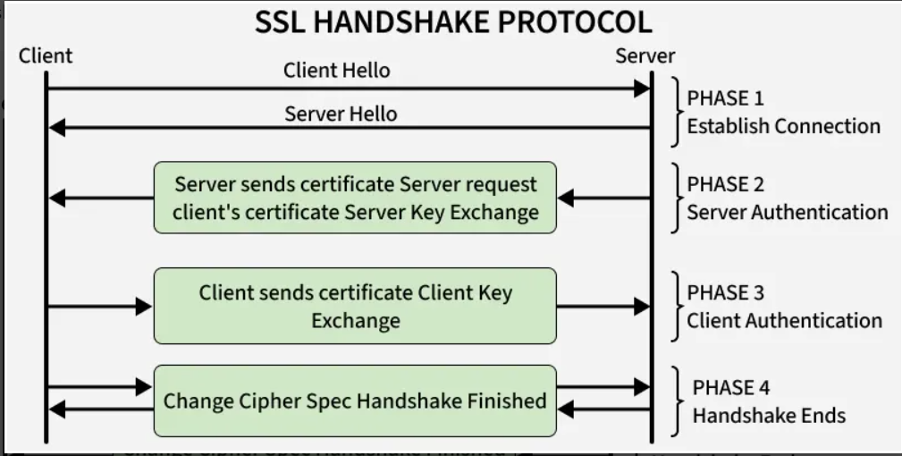
SSL (Secure Sockets Layer) establishes secure communication in four handshake phases: 1. Establish Security Capabilities, where client & server propose crypto methods; 2. Server Authentication & Key Exchange, server proves identity (cert) & sends public key; 3. Client Authentication & Key Exchange, client proves identity (if needed) & sends shared secret; 4. Finish, both parties confirm & start encrypted data transfer, ensuring confidentiality, integrity, and authentication for web security.
Here's a breakdown of each phase:
1. Establish Security Capabilities (ClientHello/ServerHello)
- What happens: The client initiates by sending a ClientHello message with supported SSL/TLS versions, cipher suites (encryption algorithms), and a random number. The server responds with ServerHello, choosing the best matching version and cipher suite, plus its own random number.
- Goal: Agree on the cryptographic rules (algorithms) for the session.
2. Server Authentication & Key Exchange (ServerCertificate/ServerKeyExchange/ServerHelloDone)
- What happens: The server sends its digital certificate (containing its public key) to prove its identity (authentication). If using key exchange like Diffie-Hellman, it might send parameters too.
- Goal: Client verifies the server's identity and gets its public key to securely exchange session keys.
3. Client Authentication & Key Exchange (ClientCertificate/ClientKeyExchange/CertificateVerify/ChangeCipherSpec)
- What happens: If mutual authentication is required, the client sends its certificate and a signed "finished" message (CertificateVerify). The client generates a secret, encrypts it with the server's public key, and sends it (ClientKeyExchange). Both use these keys to derive shared secret session keys.
- Goal: Authenticate the client (optional) and securely establish shared symmetric keys for data encryption.
4. Finish (ChangeCipherSpec/Finished)
- What happens: Both client and server send a final Finished message, encrypted with the new session keys, signaling the handshake is complete.
- Goal: Confirm everything is set, switch to encrypted communication, and begin secure data transfer (application data) using the established session keys.
Q. Explain IP security protocols AH and EPS in detail.
In IP security (IPsec), AH (Authentication Header) provides data integrity, source authentication, and anti-replay by hashing the entire IP packet (header+data) but offers no encryption, leaving data visible; while ESP (Encapsulating Security Payload) offers confidentiality (encryption), integrity, and authentication for the data payload, optionally protecting headers in Tunnel Mode but less of them in Transport Mode, making ESP more common for general VPN security. Both secure IP traffic at the network layer, ensuring data isn't tampered with and comes from a trusted source, but differ in encryption capabilities.

Authentication Header (AH)
- Purpose: Guarantees data integrity, source authentication, and anti-replay protection for IP packets.
- How it Works: Inserts an AH field after the original IP header, containing a hash (Message Authentication Code - MAC) of the entire packet, including the (immutable) IP header fields and the payload.
- Key Feature: Authenticates the entire IP packet, but does not encrypt the data, meaning the payload remains readable.
- Use Case: Ideal when encryption isn't needed (e.g., legal constraints, performance) but strong authentication and integrity are crucial, like securing management traffic.
Encapsulating Security Payload (ESP)
- Purpose: Provides confidentiality (encryption), data integrity, authentication, and anti-replay services.
- How it Works: Encrypts the original IP payload and adds an ESP header/trailer, including an integrity check (ICV) for the encrypted data.
- Key Feature: Offers encryption (confidentiality) for the data payload, making it unreadable to eavesdroppers, plus authentication and integrity.
- Modes:
  - Transport Mode: Encrypts/authenticates only the payload; original IP header remains.
  - Tunnel Mode: Encrypts/authenticates the entire original packet and encapsulates it in a new IP packet with a new header.
- Use Case: The standard for securing VPNs (Virtual Private Networks) and general end-to-end IP traffic requiring confidentiality.
Key Differences & Usage
- Encryption: AH = No; ESP = Yes (Payload).
- Protection Scope: AH protects the whole packet; ESP protects the payload, and in Tunnel Mode, the whole packet.
- Commonality: ESP is more widely used due to encryption, often in VPNs.
- Combination: They can be used together for comprehensive security (e.g., AH for header integrity, ESP for data encryption).
Q. What is email security and why it is necessary? Explain any one algorithm used for email security
Email security protects digital messages from threats like spam, phishing, and malware using tools such as filters, encryption, and authentication, crucial because email is a primary attack vector, enabling data theft and network breaches. A key algorithm is S/MIME (Secure/Multipurpose Internet Mail Extensions), which uses asymmetric cryptography (public/private key pairs) to digitally sign (verify sender) and encrypt (scramble) emails, ensuring confidentiality and integrity, explained S/MIME by GeeksforGeeks.
What is Email Security?
It's a set of practices, policies, and technologies (like spam filters, antivirus, encryption) to safeguard email systems and data from cyber threats, unauthorized access, and malicious content.
Why is it Necessary?
- Primary Attack Vector: Email is a major entry point for ransomware, viruses, and phishing attempts.
- Data Loss: Compromised accounts lead to sensitive data exposure, financial loss, and reputational damage.
- Operational Disruption: Attacks can halt business, causing downtime and reduced productivity.
- Human Error: Phishing exploits user trust, making robust security vital to counter human mistakes.
Algorithm Example: S/MIME (Secure/MIME)
- Function: Secures email by encrypting content (confidentiality) and digitally signing messages (authentication/integrity).
- How it Works (Asymmetric Crypto):
  - Key Pair: Each user has a public key (shared) and a private key (secret).
  - Encryption (Sending): Sender encrypts message with the recipient's public key.
  - Decryption (Receiving): Only the recipient's private key can decrypt it, ensuring only they read it.
  - Digital Signature (Sending): Sender encrypts a hash of the message with their private key, proving authenticity.
  - Verification (Receiving): Recipient uses the sender's public key to decrypt the hash, confirming the sender and that the message wasn't altered.
Q. Illustrate the components of SSL with a clear diagram, and elucidate the distinctions between an SSL connection and an SSL session?
SSL uses protocols like Record, Handshake, and Alert with asymmetric (keys/certs) & symmetric encryption (session key) for secure links, differentiating from a Session (negotiated params for reuse) vs. Connection (actual live channel). The Handshake sets up the session (auth/keys), then Record encrypts data, while Change Cipher Spec activates settings, and Alerts handle errors, creating a secure, stateful link (connection) from a session's parameters.

SSL Protocol Components Explained
- Handshake Protocol: The negotiation phase.
  - Client/Server "hellos" (protocol/cipher choices).
  - Server sends certificate & public key.
  - Client verifies cert, sends its own key exchange.
  - Master secret derived, session key generated (symmetric).
- Change Cipher Spec Protocol: A single-byte message signaling activation of new cryptographic parameters.
- Record Protocol: Handles data transfer.
  - Application data fragmented, compressed, MAC added (integrity).
  - Encrypted with session key (confidentiality).
  - SSL Header added for transmission.
- Alert Protocol: Communicates errors (warnings/fatal) to terminate session if needed.
SSL Session vs. SSL Connection
- SSL Session: A set of negotiated security parameters (cipher suite, keys, session ID) that define a secure state, stored for potential reuse to speed up future connections (session resumption).
- SSL Connection: The actual, live, secure communication channel between client and server, established using parameters from a session. A session can support multiple connections, but a connection is tied to one session's parameters.
Feature | SSL Connection | SSL Session
Nature | A transient (short-lived) peer-to-peer communication link. | A long-term, logical association between a client and server.
Purpose | To provide a secure channel for immediate data transfer using the session's parameters. | To define and maintain a set of shared security parameters for efficiency and reuse.
Creation | Established over a reliable transport (usually TCP) once session parameters are agreed upon. | Created by the SSL/TLS Handshake Protocol, an initial negotiation process.
Lifespan | Lasts only as long as the specific communication channel is open (e.g., a single HTTP request/response). | Can persist across multiple connections, even after a connection is closed, allowing for resumption.
Parameters | Uses specific, dynamically generated keys (write keys, MAC secrets) derived from the session's master secret. | Defines the core security parameters: session ID, cipher suite, compression method, peer certificates, and the master secret.
Efficiency | The actual data transfer channel. | Allows for "session resumption" (abbreviated handshake), avoiding the expensive full negotiation process for new connections, which improves performance.

Q. What functionalities does IPSec offer, and what are the contrasting characteristics between Transport mode and Tunnel mode within IPSec?
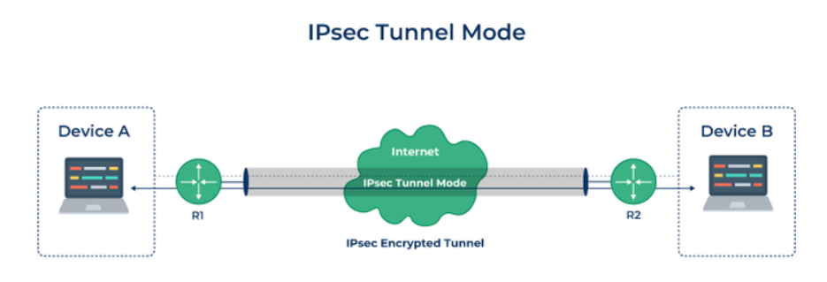
IPSec provides secure IP communication via authentication, integrity, and confidentiality (encryption), offering two main modes: Tunnel Mode, which encrypts the entire original packet (header + data) with a new IP header, ideal for site-to-site VPNs (gateway-to-gateway); and Transport Mode, which encrypts only the payload, leaving the original IP header intact, best for end-to-end host-to-host security (client-to-server). Tunnel mode hides internal routing (better security), while Transport mode has lower overhead and better MTU for direct links.

IPSec Functionalities
- Authentication: Verifies sender identity and data origin.
- Integrity: Ensures data hasn't been altered during transit (using hashes).
- Confidentiality (Encryption): Protects data from eavesdropping.
- Anti-Replay Protection: Prevents attackers from capturing and re-sending packets.
IPSec Modes: Transport vs. Tunnel
Feature | Transport Mode | Tunnel Mode
Encryption | Encrypts only the payload (data). | Encrypts the entire original IP packet (header + payload).
Header | Original IP header remains unaltered, allowing routers to see destination. | A new IP header is added, hiding internal network details.
Use Case | Host-to-Host, Client-to-Server (e.g., secure email, file transfer). | Site-to-Site VPNs (gateway-to-gateway), Remote Access VPNs.
Security | Provides end-to-end security for specific hosts. | Hides internal routing, offers better protection against traffic analysis.
Overhead/MTU | Lower overhead, larger Maximum Transmission Unit (MTU). | Higher overhead (extra header), smaller MTU.
Compatibility | Less compatible with security gateways. | More compatible with gateways, better for traversing NATs.

Q. Discuss working of PKI in detail.
Public Key Infrastructure (PKI) secures digital interactions using asymmetric cryptography (public/private keys) and digital certificates, establishing trust by verifying identities (users, devices) and ensuring data Confidentiality, Integrity, Authenticity, Non-Repudiation (CIA-N) through a system of CAs, RAs, and policies, functioning like digital IDs to enable secure web browsing (SSL/TLS), email, and transactions by binding identities to keys.
Core Concepts
- Asymmetric Cryptography: Uses a pair of mathematically linked keys: a public key (shareable) for encryption/verification and a private key (secret) for decryption/signing.
- Digital Certificates (X.509): Electronic documents linking a public key to an identity (person, server, device), signed by a trusted third party (CA).
- Certificate Authority (CA): A trusted entity that issues, revokes, and manages digital certificates, acting as the root of trust.
- Registration Authority (RA): Verifies user/entity requests before the CA issues certificates.
How PKI Works: The Process
- Key Generation: A user/device generates a public/private key pair.
- Request & Verification: The entity requests a digital certificate from a CA, proving its identity via an RA.
- Certificate Issuance: The CA verifies the request and issues a digital certificate containing the public key and identity, signed by the CA's private key.
- Secure Communication (Encryption):
  - Sender gets recipient's public key/certificate.
  - Encrypts data with recipient's public key.
  - Recipient uses their private key to decrypt.
- Digital Signing (Authentication/Integrity):
  - Sender uses their private key to sign (hash & encrypt) data.
  - Recipient uses sender's public key (from certificate) to verify the signature, ensuring authenticity and that data hasn't changed.
Key Security Goals Achieved
- Confidentiality: Encryption keeps data secret (e.g., SSL/TLS for websites).
- Integrity: Digital signatures prevent tampering.
- Authentication: Certificates verify identities, preventing imposters (e.g., fake websites).
- Non-Repudiation: Signed transactions can't be denied.
PKI Applications in Cyber Security
- SSL/TLS: Secures web traffic (HTTPS).
- Email Security: S/MIME for secure, signed emails.
- Device Authentication: Securing IoT devices.
- Code Signing: Verifies software publisher authenticity.
- VPNs & Network Access: Authenticating users/devices joining a network.
In essence, PKI creates a verifiable chain of trust, allowing strangers on the internet to securely exchange data and verify identities, forming the bedrock of modern digital security.
Q. What is Firewall? What are its types and list out its various functionalities.
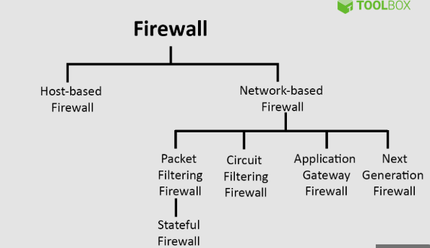
A firewall is a network security system, either hardware or software, that acts as a barrier, monitoring and filtering incoming/outgoing traffic between trusted internal networks and untrusted external ones (like the internet) based on predefined security rules, preventing unauthorized access and malicious threats like malware. Key types include Packet Filtering, Stateful Inspection, Proxy (Application-Level), Next-Generation (NGFW), and Web Application Firewalls (WAFs). Its main functions involve blocking unauthorized access, preventing malware, controlling network usage, logging activity, and segmenting networks for better security.

Types of Firewalls
- Packet Filtering Firewall: Inspects data packets based on IP addresses, ports, and protocols, making quick allow/deny decisions.
- Stateful Inspection Firewall: Tracks active connections (state) to provide more context than packet filtering, blocking suspicious sessions.
- Proxy Firewall (Application-Level Gateway): Acts as an intermediary, inspecting application-layer traffic for specific protocols (like HTTP) to provide deep content filtering.
- Next-Generation Firewall (NGFW): Combines traditional firewall features with advanced capabilities like Deep Packet Inspection (DPI), intrusion prevention (IPS), and application awareness.
- Web Application Firewall (WAF): Specifically protects web applications from attacks like SQL injection and Cross-Site Scripting (XSS).
- Host-Based Firewall: Software running on individual devices (computers, servers) for device-level protection.
- Network-Based Firewall: Hardware or software placed at the network perimeter to protect all devices behind it.
Key Functionalities
- Traffic Filtering & Control: Blocks unwanted traffic (malware, hackers) and allows legitimate data based on rules.
- Unauthorized Access Prevention: Creates a secure perimeter, stopping external entities from entering the private network.
- Malware & Threat Defense: Stops viruses, worms, phishing attempts, and DoS attacks from reaching internal systems.
- Network Segmentation: Divides a network into zones (e.g., DMZ) to isolate sensitive data and contain breaches.
- Logging & Auditing: Records network activity, providing logs for security analysis, compliance, and refining rules.
- Policy Enforcement: Implements security policies, like blocking social media or certain applications, for better control.
- VPN Support: Facilitates secure remote access for users through Virtual Private Networks.
Q. Differentiate between PGP and S/MIME.
Feature | PGP | S/MIME
Design | Primarily designed for processing plain text. | Designed to process both emails and multimedia files.
Cost | Less expensive compared to S/MIME. | More expensive due to reliance on certificates and infrastructure.
Use Case | Suitable for personal and office use. | Primarily used in industrial environments and large organizations.
Efficiency | Less efficient than S/MIME. | More efficient, especially in enterprise environments.
Key Exchange | Depends on user key exchange (e.g., Web of Trust). | Relies on a hierarchically valid certificate (PKI) for key exchange.
Convenience | Less convenient due to manual setup and key management. | More convenient with secure, automated transformation of applications.
Public Keys | Typically supports up to 4096-bit public keys. | Generally uses smaller 1024-bit public keys.
Encryption Standard | Recognized as a standard for strong encryption. | Also a standard for strong encryption, but with some limitations.
Use in VPNs | Can be used in VPNs. | Primarily used for email services, not in VPNs.
Digital Signature | Uses the Diffie-Hellman algorithm for digital signatures. | Uses the Elgamal algorithm for digital signatures.
Trust Model | Trust is established using a Web of Trust model. | Trust is established using a Public Key Infrastructure (PKI).
Security Scope | Primarily used for securing text messages. | Secures both messages and attachments.
Industry Adoption | Less widely adopted in industry. | More widely used in industry, particularly for email security.
Convenience | Lower convenience due to more manual steps. | Higher convenience, particularly in corporate environments.
Administrative Overhead | Higher administrative overhead due to manual key management. | Lower administrative overhead thanks to centralized certificate management

Q. Explain the web security in detail.
Web security in cybersecurity protects websites, users, networks, and data from internet threats like malware, phishing, and breaches, using layered defenses such as firewalls, HTTPS encryption, authentication, access controls, and software updates to ensure data confidentiality, integrity, and availability, covering network, transport, and application layers. It involves protecting the entire digital ecosystem from threats like viruses, scams, and complex attacks, safeguarding sensitive information and business continuity.
Core Components & Concepts
- Authentication & Authorization: Verifying user identities (passwords, 2FA) and controlling access to resources.
- Encryption (TLS/SSL): Securing data in transit between browsers and servers (HTTPS).
- Firewalls (WAFs): Filtering malicious traffic to and from web applications.
- Intrusion Detection/Prevention Systems (IDPS): Monitoring for and blocking suspicious network activity in real-time.
- Malware Protection: Antivirus/anti-malware to detect and remove malicious software.
- URL Filtering & Sandboxing: Blocking access to harmful sites and isolating risky browsing.
- Same-Origin Policy: Browser mechanism isolating different website data from each other.
Key Threats
- Phishing: Tricking users into revealing sensitive info.
- Malware: Viruses, ransomware, spyware.
- DDoS Attacks: Overwhelming services with traffic to cause outages.
- Data Breaches/Theft: Unauthorized access and exfiltration of data.
- Vulnerabilities: Flaws in code or systems (e.g., SQL Injection, XSS) that attackers exploit.
Implementation & Best Practices
- Regular Updates & Patching: Fix known software vulnerabilities.
- Strong Passwords & 2FA: Protect user accounts.
- Secure Configuration: Use HTTPS, strong access controls, secure cloud settings.
- Security Testing: Penetration testing, code analysis (white-box).
- User Education: Train people to recognize threats like phishing.
- Data Backups: Ensure recovery from data loss.
Layers of Defense (TCP/IP Stack)
- Network Layer: IPSec for general network security.
- Transport Layer: TLS/SSL for securing communication (HTTPS).
- Application Layer: Application-specific security (e.g., securing email, APIs, web apps).

Unit : 6
Q. What is an Intrusion Detection System? Describe types of IDS based on method of Detection?
An Intrusion Detection System (IDS) is a security tool monitoring networks/systems for malicious activity, alerting admins to threats, acting like a "watchful eye" by spotting unauthorized access or policy violations. Based on detection method, IDSs use Signature-Based (matching known attack patterns) and Anomaly-Based (spotting deviations from normal behavior) approaches, with some also using Hybrid (combining both) or advanced techniques like Stateful Protocol Analysis to identify threats.
What is an IDS?
- Definition: A system (software/hardware) that passively monitors network traffic or system logs for suspicious patterns, policy violations, or known threats.
- Function: Detects potential security incidents (intrusions) and reports them, unlike an IPS (Intrusion Prevention System) which actively blocks them.
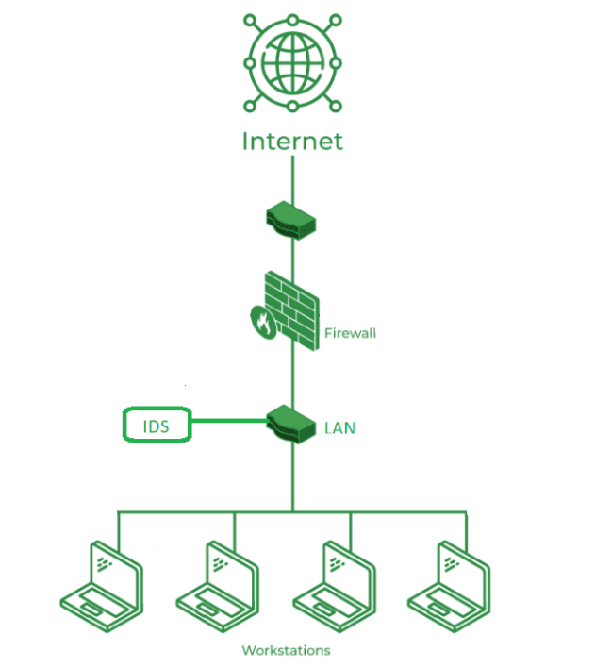
- Goal: Provide visibility into security events for IT teams to investigate and respond.

Types of IDS by Detection Method:
- Signature-Based Detection (Misuse Detection)
- How it works: Compares observed activity against a database of known attack patterns or "signatures" (like virus definitions).
  - Pros: Highly effective at catching known attacks, fewer false positives.
  - Cons: Cannot detect new, unknown (zero-day) attacks.
- Anomaly-Based Detection (Behavioral Detection)
  - How it works: Establishes a baseline of "normal" network/system behavior and flags any significant deviations or anomalies as potential threats.
  - Pros: Can detect novel attacks or unusual behavior.
  - Cons: Higher false positive rate as legitimate new activities might be flagged.
- Hybrid Detection
  - How it works: Combines signature-based and anomaly-based methods for comprehensive coverage, blending accuracy with the ability to find new threats.
- Stateful Protocol Analysis
  - How it works: Analyzes protocol states (e.g., TCP connection stages) to detect misuse by comparing traffic against normal protocol behavior, going deeper than simple signature matching.
- Threat Intelligence Feeds
  - How it works: Uses external data on known malicious IPs, domains, or malware to identify threats in real-time.
Common IDS Types by Placement:
- Network-Based IDS (NIDS): Monitors traffic across the entire network.
- Host-Based IDS (HIDS): Monitors activity on individual endpoints (hosts).
Q. Give short note on IDS.
An Intrusion Detection System (IDS) is like a digital security guard for your computer network, constantly watching traffic for bad guys (hackers, malware) or weird behavior, then alerting you when it finds trouble, rather than stopping it directly. It uses methods like matching known attack patterns (signatures) or spotting unusual activity (anomalies) to flag threats, keeping your systems safer by giving admins a heads-up.

What it is & How it Works (Simple Terms)
- Digital Watchdog: An IDS is software or hardware that "listens" to network traffic, looking for anything suspicious.
- Spotting Trouble: It checks for known virus codes (signatures) or detects when something behaves strangely, like a user suddenly accessing huge files.
- Alerts & Logs: When it finds something bad, it sends an alert (like a siren) to security teams and logs the event, so admins can investigate.
Key Types
- Network-based (NIDS): Watches all traffic flowing across the network.
- Host-based (HIDS): Monitors a specific computer or device (like a server) for internal issues.
How it Detects (Methods)
- Signature-based: Looks for specific "signatures" (patterns) of known attacks, like an antivirus finding a virus.
- Anomaly-based: Learns what "normal" looks like and flags anything that deviates from that baseline.
IDS vs. IPS (Important Distinction)
- IDS (Detects & Alerts): A passive listener; it reports but doesn't stop the attack.
- IPS (Intrusion Prevention System): A more active system that can automatically block malicious traffic once detected.
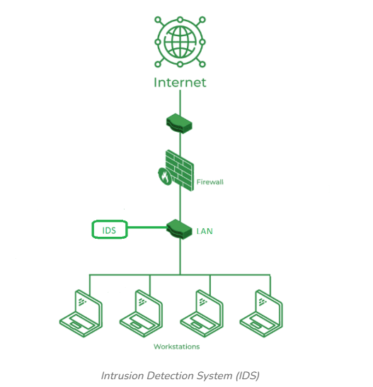

- An IDS (Intrusion Detection System) monitors the traffic on a computer network to detect any suspicious activity.
- It analyzes the data flowing through the network to look for patterns and signs of abnormal behavior.
- The IDS compares the network activity to a set of predefined rules and patterns to identify any activity that might indicate an attack or intrusion.
- If the IDS detects something that matches one of these rules or patterns, it sends an alert to the system administrator.
- The system administrator can then investigate the alert and take action to prevent any damage or further intrusion.

- Classification of Intrusion Detection System(IDS)
Network Intrusion Detection System (NIDS): Network intrusion detection systems (NIDS) are set up at a planned point within the network to examine traffic from all devices on the network.
Host Intrusion Detection System (HIDS): Host intrusion detection systems (HIDS) run on independent hosts or devices on the network. A HIDS monitors the incoming and outgoing packets from the device only and will alert the administrator if suspicious or malicious activity is detected
Hybrid Intrusion Detection System: Hybrid intrusion detection system is made by the combination of two or more approaches to the intrusion detection system .In the hybrid intrusion detection system, the host agent or system data is combined with network information to develop a complete view of the network system.
Application Protocol-Based Intrusion Detection System (APIDS): An application Protocol-based Intrusion Detection System (APIDS) is a system or agent that generally resides within a group of servers.
Protocol-Based Intrusion Detection System (PIDS): It comprises a system or agent that would consistently reside at the front end of a server, controlling and interpreting the protocol between a user/device and the server.
Signature-Based Detection: Signature-based detection checks network packets for known patterns linked to specific threats. A signature-based IDS compares packets to a database of attack signatures and raises an alert if a match is found

Q. Define list and explain differrent types of worms.
In cybersecurity, a worm is self-replicating malware that spreads across networks by exploiting vulnerabilities, unlike viruses, it doesn't need a host file but spreads autonomously, consuming bandwidth and resources, with types classified by propagation: Email Worms (via attachments like ILOVEYOU), Internet/Network Worms (exploiting system flaws like Conficker), P2P/File-Sharing Worms (disguised in downloads on networks like Napster), Instant Messaging Worms (through IM apps), IRC Worms (using chat rooms), and Crypto Worms (encrypting data for ransom).
What is a Worm?
A computer worm is a standalone malware that self-replicates and spreads to other computers, often consuming network bandwidth and system resources, and can carry damaging payloads, like deleting files or installing backdoors. Its key feature is autonomous propagation, exploiting security flaws or human error.
Types of Worms (by Propagation Method)
- Email Worms: Spread via infected email attachments or links, tricking users into opening them, like the famous "ILOVEYOU" worm.
- Internet/Network Worms: Exploit vulnerabilities in network services (like Windows flaws) to spread rapidly across LANs/WANs, e.g., Conficker.
- File-Sharing/P2P Worms: Hide in shared folders or P2P networks, disguised as legitimate files (movies, songs) for users to download.
- Instant Messaging (IM) Worms: Propagate through IM platforms by sending malicious links or attachments to contacts.
- IRC Worms: Utilize Internet Relay Chat channels to distribute infected files or links.
- USB/Removable Media Worms: Spread through infected flash drives and other portable storage devices.
- Crypto Worms: A modern type that encrypts user data and demands ransom for decryption, combining with ransomware tactics.
- Blended Threat Worms: Combine features of worms with other malware (viruses, Trojans) for broader attacks.
Q. What is a phishing attack explain with an example. What are the different types of phishing?
A phishing attack tricks victims into revealing sensitive data (passwords, bank info) by impersonating trusted entities via fake emails, texts, or sites, like a fake bank alert asking you to "verify" your login on a spoofed website to steal your credentials. Key types include Spear Phishing (targeted), Smishing (SMS), Vishing (voice), Clone Phishing (perfect copies), and Whaling (high-profile targets), all using social engineering to exploit human trust for financial gain or data theft.
What is a Phishing Attack?
Phishing uses deceptive messages (emails, texts, calls) to lure you into clicking malicious links, downloading infected files, or entering personal details on fake websites that look real, ultimately stealing your information or installing malware.
Example:
You receive an email that looks exactly like it's from your bank, saying, "Your account has suspicious activity! Click here to verify your details immediately." The link leads to a website identical to your bank's login page, but when you enter your username and password, the attacker captures them instead of logging you in.
Common Types of Phishing Attacks
- Email Phishing: Broad attacks via fake emails (e.g., shipping notices, password resets).
- Spear Phishing: Highly personalized attacks targeting specific individuals using gathered info (job, name).
- Whaling (Whale Phishing): Targets senior executives (the "whales") for major data breaches or financial fraud.
- Vishing (Voice Phishing): Using phone calls or voicemail to trick victims (e.g., fake IRS calls).
- Smishing (SMS Phishing): Fraudulent text messages, often with urgent links.
- Clone Phishing: Duplicating a legitimate, previously sent email but replacing a safe link with a malicious one.
- Pharming: Redirects users to fake sites even if they type the correct URL (DNS poisoning).
- Evil Twin: Setting up fake Wi-Fi hotspots that mimic legitimate ones to intercept data.
- Crypto Phishing: Focuses on stealing cryptocurrency wallets or login credentials for crypto exchanges.
Q. Explain following terms - i) SQL injection ii) Spyware iii) Adware iv) Ransomware
i) SQL injection
SQL injection (SQLi) is a type of attack where a hacker inserts malicious SQL (Structured Query Language) code into a data entry field on a website or application [1]. This code can trick the database into executing unintended commands.
- Simple analogy: It's like a burglar adding special instructions to a key to not only open a locked door but also open the safe inside the room, allowing them to view, modify, or delete sensitive data like user passwords or credit card information [1].
ii) Spyware
Spyware is malicious software designed to secretly monitor and record your computer activities without your knowledge or consent [1].
- Simple analogy: It's like having a private investigator secretly follow you around, taking notes on everything you do online—which websites you visit, what you type (including usernames and passwords), and who you email—and sending that information back to a third party [1].
iii) Adware
Adware (advertising-supported software) is software that automatically displays unwanted pop-up advertisements or banners on your computer [1]. While some adware is merely annoying, other, more malicious forms can track your browsing habits to target specific ads at you and may slow down your computer [1].
- Simple analogy: It's like opening a free magazine that's suddenly full of giant, unskippable pop-up ads that get in the way of the content you actually want to see.
iv) Ransomware
Ransomware is a type of malicious software that encrypts (locks) a victim's files or locks them out of their computer system entirely, making their data inaccessible [1]. The attacker then demands a payment (ransom) in exchange for the decryption key or access restoration [1].
- Simple analogy: It's like someone putting a strong padlock on your entire house or car and refusing to give you the key until you pay them a sum of money.
Q. Define computer worms and viruses, explain the mechanisms through which computer viruses spread, and outline effective strategies for safeguarding against these cybersecurity threats?
Computer viruses attach to host files needing user action to spread, while worms are standalone malware that self-replicate across networks autonomously, exploiting vulnerabilities. Viruses spread via infected attachments, downloads, and shared files; worms propagate through networks, exploiting system weaknesses. Safeguards include antivirus software, timely updates, caution with links/attachments, firewalls, and user education.
Computer Viruses
- Definition: Malicious code that inserts itself into legitimate files or programs (hosts).
- Mechanism: Requires human interaction (opening an infected file, clicking a link) to activate and spread to other files on the system or network.
Computer Worms
- Definition: Self-contained, self-replicating malware that operates independently.
- Mechanism: Spreads automatically across networks by exploiting system vulnerabilities, consuming bandwidth and resources, and infecting other devices without user help.
How They Spread (Mechanisms)
- Viruses: Email attachments, infected websites, P2P file sharing, downloads from untrusted sources, infected USB drives.
- Worms: Network connections, exploiting software flaws, infected USBs, malicious links/attachments.
Safeguarding Strategies (Cybersecurity Best Practices)
- Use Antivirus/Anti-Malware: Install and keep updated trusted security software for regular scans.
- Keep Software Updated: Patch operating systems and applications to close security holes.
- Be Cautious Online: Avoid suspicious email attachments, links, and pop-up ads.
- Use Firewalls: Implement network firewalls to block unauthorized access.
- Download Safely: Only download from reputable sources.
- Educate Users: Train people to recognize threats and practice safe computing.
- Isolate Infections: Disconnect from the internet immediately if an infection is suspected.
Q. What is Malware? Enlist different types of malware. What precaution needs to protect from malware
Malware (malicious software) is code designed to harm systems, steal data, or disrupt operations, with types including viruses (self-replicating), worms (network-spreading), ransomware (encrypts for ransom), spyware (spies on users), trojans (disguised), and adware (unwanted ads). To protect against it, use strong antivirus, keep software updated, back up data, be wary of suspicious links/attachments, use strong passwords, enable MFA, and limit application permissions.
Types of Malware
- Viruses: Attach to clean files and spread when those files are executed, corrupting data or systems.
- Worms: Self-replicating and spread across networks without user action, consuming bandwidth.
- Trojans: Disguised as legitimate software to trick users into installing them, then steal data or create backdoors.
- Ransomware: Encrypts files, demanding payment for their release.
- Spyware/Keyloggers: Secretly monitors activity, steals passwords, and records keystrokes.
- Adware: Displays unwanted advertisements, often slowing performance.
- Botnets: Networks of infected computers (bots) controlled by an attacker.
- Rootkits: Hide malicious processes and files from detection.
- Cryptojackers: Steal computing power to mine cryptocurrency.
Protection & Prevention (Cybersecurity)
- Software & Systems: Keep OS, antivirus, and applications updated; use reputable security software.
- User Behavior: Avoid clicking suspicious links, opening unknown attachments, or downloading from untrusted sources.
- Access Control: Use strong, unique passwords and Multi-Factor Authentication (MFA).
- Data Safety: Regularly back up important files offline or to secure cloud storage.
- System Settings: Limit application privileges and monitor for unexpected pop-ups or high resource usage.
- Network Security: Use intrusion detection systems for monitoring suspicious traffic.
Q. Explain in detail SQL injection attach.
SQL injection (SQLi) is a critical web security vulnerability that allows an attacker to interfere with the queries an application makes to its database. It generally allows an attacker to view data they are not normally able to retrieve, and in many cases, modify or delete this data, causing persistent changes to the application's content and behavior [1].
Detailed Explanation
The core of an SQL injection attack lies in the application's failure to properly sanitize user-supplied data before incorporating it into an SQL query.
- Vulnerable Code: A common example involves dynamic query construction where user input is directly concatenated into the query string.
  - Example (Vulnerable PHP):
php
$username = $_POST['username'];
$query = "SELECT * FROM users WHERE username = '" . $username . "'";
$result = mysqli_query($conn, $query);
- The Attack: An attacker doesn't provide a typical username (e.g., admin). Instead, they input malicious SQL syntax designed to manipulate the query's logic.
  - Example Input: ' OR '1'='1
- The Resulting Query: When this input is processed, the actual SQL query executed by the database becomes:
sql
SELECT * FROM users WHERE username = '' OR '1'='1'
- Database Execution: The database evaluates this query. Since '1'='1' is always true, the WHERE clause condition is true for every row in the users table, effectively bypassing the login requirement and returning all user records [1].
Types of SQL Injection
SQL injection attacks are generally classified into three main categories based on how the attacker retrieves data from the database [1]:
- In-band SQLi (Classic SQLi): The most common type, where the attacker uses the same communication channel to launch the attack and gather results. This includes:
  - Error-based SQLi: The attacker relies on error messages generated by the database server to obtain information about its structure or the data itself [1].
  - Union-based SQLi: The attacker uses the UNION SQL operator to combine the results of the original (legitimate) query with the results of a malicious query they control, returning data within the application's normal response [1].
- Inferential SQLi (Blind SQLi): The application does not return the data directly in the HTTP response. The attacker asks the database true/false questions and determines the answer based on the application's response (or lack thereof).
  - Boolean-based: The attacker observes whether the application returns a different page or content depending on whether the query returns true or false [1].
  - Time-based: The attacker forces the database to wait a specified amount of time (e.g., using SLEEP() or WAITFOR DELAY commands) if a condition is true. The attacker determines the answer by measuring the time the server takes to respond [1].
- Out-of-band SQLi: The attacker can't use the same channel to launch the attack and gather results (because the server response is unstable or inexistent). The attacker forces the database to send the data to a remote server they control, typically via DNS or HTTP requests initiated by the database itself [1].
Prevention and Mitigation
The primary defense against SQL injection is to ensure that user input is never treated as executable code by the database engine.
- Parameterized Queries (Prepared Statements): This is the most effective defense. It separates the code from the data. The developer defines the SQL query structure in advance, and user inputs are handled as parameters (data), not as part of the SQL command itself [1]. The database driver ensures the input is properly escaped.
- Stored Procedures: Similar to prepared statements, stored procedures define the SQL logic on the database server.
- Input Validation/Sanitization: Implement strict allow-lists for user input wherever possible. Ensure data conforms to expected types, lengths, and formats.
- Principle of Least Privilege: Ensure the database user account used by the application has only the minimum necessary permissions required to function. It should not have administrative privileges [1].

Q. What is Virus? What are the types of virus?
In cybersecurity, a virus is malicious code that attaches to legitimate files, replicates, and spreads to other programs/systems, causing damage like data corruption or system disruption, often relying on human action (like opening attachments) to spread; common types include Boot Sector, Macro, File Infector, Resident, Polymorphic, Multipartite, and Web Scripting viruses, each with unique infection methods, though the term "virus" is often used broadly for all malware like Trojans, Worms, Ransomware.
What is a Virus?
- A computer virus is a form of malware designed to insert its code into clean files or programs, modifying them to execute the virus's malicious payload when the infected file is opened.
- It requires a host program/file and human interaction to spread, unlike worms, which spread independently.
- Its goals include stealing data, disrupting operations, corrupting files, or creating backdoors.
Types of Viruses (and Malware)
- Boot Sector Virus: Infects the master boot record (MBR) or boot sector, loading into memory before the OS.
- Macro Virus: Written in macro languages (like VBA) and infects templates or documents (e.g., Word, Excel).
- File Infector Virus: Attaches to executable files (.exe, .com).
- Resident Virus: Hides in system memory (RAM) to infect files as they are accessed.
- Multipartite Virus: Can infect both boot sectors and program files.
- Polymorphic Virus: Changes its signature (code) with each infection to evade detection.
- Web Scripting Virus: Exploits vulnerabilities in web browsers.
- Browser Hijacker: Changes browser settings, redirects searches, or displays ads.
Related Malware (Often Called Viruses)
- Worms: Self-replicating malware that spreads across networks without a host file.
- Trojans: Disguised as legitimate software to trick users into installing them.
- Ransomware: Encrypts files and demands payment for their release (e.g., CryptoLocker, WannaCry).
- Spyware/Adware: Secretly collects user data or displays unwanted ads.
Q. Discuss buffer overflow, spyware, adware in detail.
Buffer overflow, spyware, and adware are key cybersecurity threats: Buffer Overflows are coding errors where too much data overfills memory, letting attackers inject malicious code to hijack programs. Spyware secretly spies on users, stealing data like passwords and financial info. Adware bombards users with unwanted ads, often bundled with free software, slowing systems and posing privacy risks. All three exploit software weaknesses or user behavior to compromise systems and steal data.

1. Buffer Overflow
- What it is: A common software vulnerability where a program tries to write more data into a fixed-size memory area (a buffer) than it can hold, causing the excess data to "overflow" into adjacent memory locations.
- How it works: Attackers send specially crafted, oversized inputs that overwrite critical data, including the program's execution pointer.
- Impact: Can crash programs, corrupt data, cause errors, or, most dangerously, allow attackers to execute their own malicious code, taking control of the system.
- Examples: The 1988 Morris Worm and the WannaCry ransomware used buffer overflows to spread.
- Prevention: Using memory-safe languages (Java, Python), proper bounds checking, and OS-level protections like Data Execution Prevention (DEP) and Address Space Layout Randomization (ASLR).
2. Spyware
- What it is: Malicious software designed to secretly monitor and collect user information without consent, sending it to third parties.
- How it works: Often bundled with legitimate-looking software or disguised in emails, it runs hidden in the background, logging keystrokes (keyloggers), capturing screenshots, and stealing browsing habits.
- Impact: Identity theft, financial fraud, unauthorized access to accounts, and significant privacy violations.
- Examples: Keyloggers, information stealers, and browser hijackers.
- Prevention: Antivirus/anti-malware software, caution with downloads, strong passwords, and enabling browser security features.
3. Adware
- What it is: Software that automatically displays or downloads unwanted advertisements, often delivered through pop-ups or redirects.
- How it works: Typically installed alongside free software (bundled), it tracks browsing activity and displays targeted ads, slowing down performance and consuming bandwidth.
- Impact: Annoying user experience, system slowdown, privacy risks (tracking), and can sometimes lead to more malicious infections (like spyware).
- Examples: Toolbar hijackers, pop-up generators, and software that changes your search engine.
- Prevention: Carefully read license agreements, avoid bundled software, use ad blockers, and run anti-malware scans.

In essence, buffer overflows exploit code flaws, while spyware and adware manipulate users or software to gain access, all leading to data compromise or system disruption.
Q. Discuss Worms, DoS and DDoS in detail.
Worms
A worm is a type of malicious software (malware) that can self-replicate and spread to other computers without human interaction [1, 2]. Unlike a virus, which requires a host program or user action to spread, a worm is a standalone program [2].
- Mechanism: Worms often exploit vulnerabilities in software or operating systems to infect systems [2]. They can use network protocols to search for and compromise other vulnerable machines.
- Impact: Beyond just spreading, worms can carry a "payload" designed to cause damage, such as stealing sensitive data, deleting files, or installing other malicious software like backdoors, allowing attackers remote access [1, 2].
- Analogy: Imagine a self-propagating paper airplane that flies from office to office without anyone throwing it, dropping off a smaller, destructive paper clip in each room it enters.
DoS (Denial-of-Service)
A Denial-of-Service (DoS) attack is a cyberattack that aims to make a service or website unavailable to its intended users by overwhelming it with traffic or exploiting a specific vulnerability [3, 4].
- Mechanism: The attack originates from a single source or a small number of machines [3]. It floods the target with requests, consuming all available bandwidth, memory, or processing power, thus preventing legitimate users from accessing the service [4].
- Impact: The primary impact is the disruption of service, leading to potential financial losses for businesses and frustration for users [3, 4].
- Analogy: One person repeatedly calling a small shop's only phone line, preventing any real customers from getting through.
DDoS (Distributed Denial-of-Service)
A Distributed Denial-of-Service (DDoS) attack is a more powerful and sophisticated version of a DoS attack [3, 4].
- Mechanism: Instead of using a single source, a DDoS attack employs multiple, geographically distributed, compromised devices (often called a "botnet" or "zombie network") to launch a coordinated attack [3]. The sheer volume of traffic from thousands or millions of machines makes the attack much harder to stop and mitigate [4].
- Impact: DDoS attacks can bring down even robust services and major websites [3, 4]. They are notoriously difficult to defend against due to the distributed nature of the source traffic, making it hard to distinguish malicious traffic from legitimate user traffic [4].
- Analogy: Instead of one person making phone calls, a thousand people (the botnet) simultaneously call the shop's phone line, completely overwhelming it.
Summary of Key Differences
Feature | Worms | DoS | DDoS
Primary Goal | Self-propagation and potential payload delivery | Disrupting a service via a single source | Disrupting a service via multiple sources
Mechanism | Exploits vulnerabilities to spread autonomously | Overloads a target's resources | Overloads a target's resources with a botnet
Origin | Spreads across networks | Single attacker device | Multiple attacker devices (botnet)

Q. Explain phishing, password cracking, key-loggers in detail.
In cybersecurity, Phishing tricks you into giving up info via fake emails/sites; Password Cracking is breaking weak passwords with tools; and Keyloggers are spyware that secretly record your typing (keystrokes) to steal passwords and data, often installed via phishing or malicious downloads, all aimed at stealing your digital identity.
Phishing (The Bait)
- What it is: A social engineering scam where attackers impersonate trusted sources (banks, friends, companies) via emails, texts (smishing), or calls (vishing).
- How it works: They create urgency or fear (e.g., "Your account is locked!") to make you click malicious links or download attachments.
- The Goal: Get you to a fake website (e.g., a fake bank login) where you enter your username/password, or install malware.
Password Cracking (The Brute Force)
- What it is: Using software to guess or break passwords to gain unauthorized access.
- How it works:
  - Dictionary Attacks: Trying common words/passwords.
  - Brute-Force: Trying every possible combination.
  - Credential Stuffing: Using stolen username/password lists from other breaches.
  - Spray Attacks: Trying a few common passwords against many accounts.
- The Goal: Find your password to log in directly to accounts like email, banking, social media.
Keyloggers (The Silent Spy)
- What it is: Malicious software (spyware) that records every keystroke you make on your keyboard.
- How it works:
  - Often hidden in attachments or installed by visiting compromised websites (drive-by downloads).
  - Silently logs everything typed (passwords, credit card numbers, private messages) and sends it to the hacker.
- The Goal: Steal sensitive information like login credentials, financial details, and private communications, giving hackers a direct path to your accounts.
How They Work Together (The Attack Chain)
- A hacker might use a Phishing email to trick you into clicking a link that installs a Keylogger.
- The Keylogger records your passwords as you type them.
- The hacker then uses those stolen passwords, potentially through Password Cracking techniques or directly, to access your accounts.
Q. Explain Password Cracking and types of Password Cracking.
Password cracking is the process of recovering passwords from data that has been stored in or transmitted by a computer system. The goal is often to gain unauthorized access to accounts, but it can also be used legitimately by system administrators to audit password security or by digital forensics experts investigating a breach. The fundamental idea is to systematically guess or calculate potential passwords until the correct one is found [1].
In simple terms, think of it like trying to open a locked box without a key: you try every possible combination until one works.
Common Types of Password Cracking
Here are the primary methods used in password cracking, explained simply:
1. Brute Force Attacks
This is the most straightforward method. The attacker tries every single possible combination of characters (letters, numbers, symbols) until they guess the correct password [1].
- Analogy: Trying every single four-digit number from 0000 to 9999 to unlock a phone.
- Effectiveness: It is guaranteed to eventually work, but it can take a very long time, especially for long, complex passwords.
2. Dictionary Attacks
Instead of trying every combination, attackers use a pre-compiled list of common words, phrases, and previously leaked passwords (a "dictionary") [1]. They attempt each word in the list to see if it works.
- Analogy: Trying every common word in a physical dictionary to open a lock that uses words as a key.
- Effectiveness: These attacks are much faster than brute force if the password is a simple, common word, name, or a slightly modified version of it.
3. Rainbow Table Attacks
This advanced method is used when systems store passwords as "hashes" (a scrambled, one-way version of the password). A rainbow table is a pre-computed database of potential passwords and their corresponding hash values [1]. The attacker simply looks up the stolen hash in the table to find the original password.
- Analogy: Having a "cheat sheet" that instantly tells you the original word for a specific scrambled word, without having to unscramble it yourself every time.
- Effectiveness: Very fast, but only works if the system is not using modern security measures like "salting" (adding random data to the password before hashing it).
4. Credential Stuffing
This is a more modern approach that leverages large-scale data breaches. Attackers take lists of usernames and passwords stolen from one website and automatically try them on many other popular websites [1].
- Analogy: Finding a key that opens a store's front door and then trying that same key on all the other doors in the shopping mall.
- Effectiveness: Highly effective because many people reuse the same password for multiple accounts.
How to Protect Yourself
The best defense against all these methods is using strong, unique passwords for every account. A strong password should be:
- Long (at least 12-14 characters).
- A mix of letters, numbers, and symbols.
- Not a common word or personal information.
Using a password manager can help you generate and store these complex passwords easily [1]. Enabling multi-factor authentication (MFA) adds a second layer of security, making even a guessed password useless without the second verification step

